Free Microsoft Office 2016 for Windows

Download and install instructions

All Queensland state school students and staff can now download multiple free copies of the Microsoft Office 2016 suite to their personal home computers and mobile devices. You can choose to install Office 2016 or upgrade from Office 2013. The below installation method is only to be used on devices which do not have the Managed Operating Environment (MOE) build installed. Do not follow these directions to install Office on a MOE device.

Please note: If you currently have Office 2013 installed, you can update to Office 2016 by following the same process.

Download, update to or install Office 2016
- Open internet browser and navigate to http://portal.office.com

- You will be prompted for your EQ username and password on the online authentication page. Type your username and password.

- Click Login.
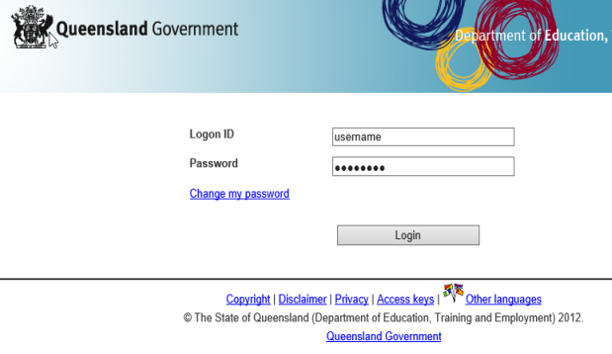

- You will need to log into the Office 365 home page using the same details listed in step 2. Ensure you enter your @eq.edu.au email address.
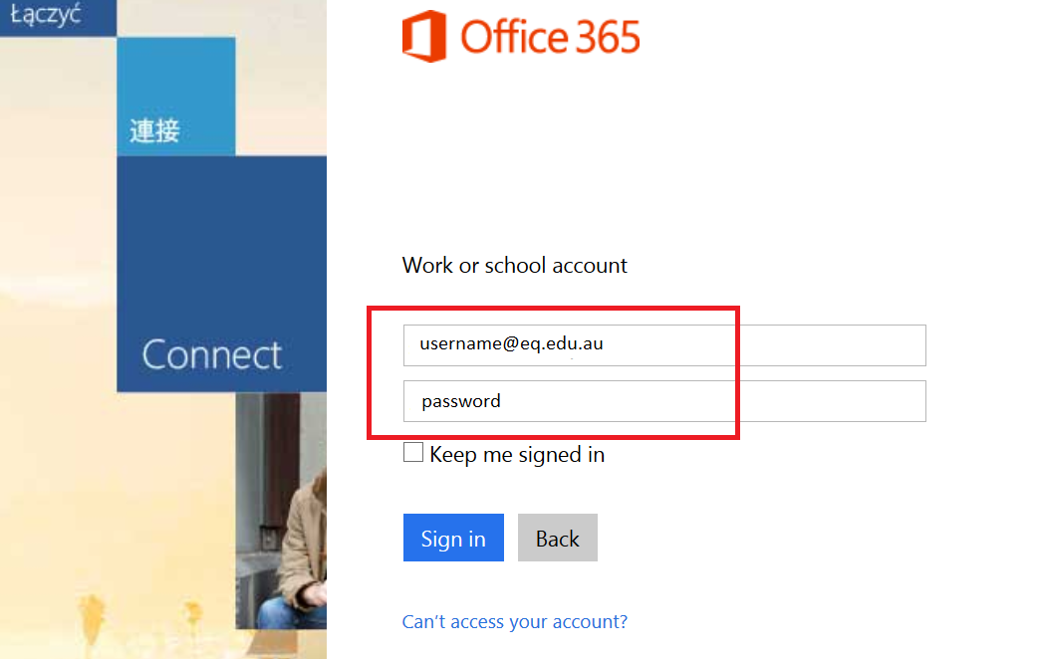

- The Install Office 2016 page will load and give you the option to ‘Install now’. Make sure you uncheck the check boxes if you don’t want to make Bing your search engine, or MSN your browser homepage. Click on the ‘Install now’ button.
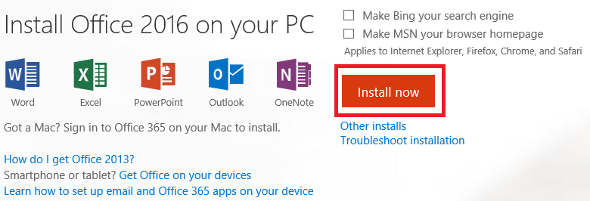

- A pop-up message will appear prompting you to run or save the .exe file. Ensure that the source is as per below — c2rsetup.officeapps.live.com.

- Click on ‘Save’. The file will automatically begin to download.

- When the file has completed downloading, click on ‘Run’.
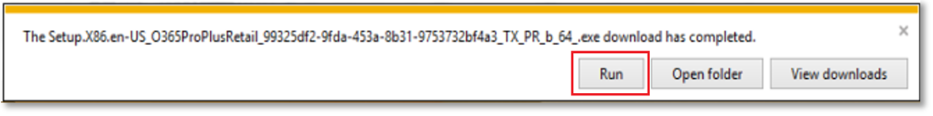
Please note this file is approx. 2gb and may take a while to download depending on your bandwidth speed.
- You will be prompted with a message to make changes to your computer. Select ‘Yes’.
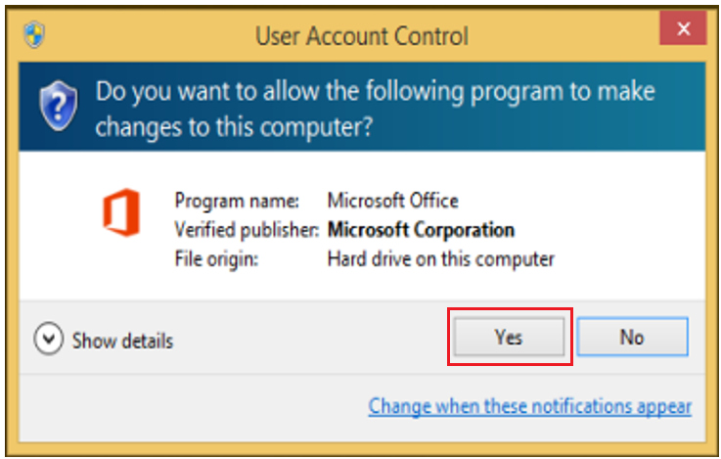

- Office will start downloading.
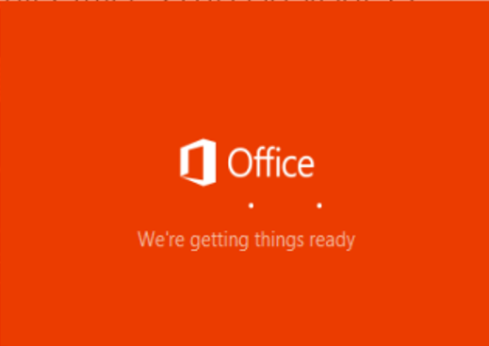

You will also see the office icon pop-up on the taskbar.

- Office 2016 will start to install onto your computer — wait for this to finish.

Please note: If you currently have Office 2013 installed, ensure all Microsoft applications are closed during the installation. You may be prompted to close all Microsoft applications if they are still open.
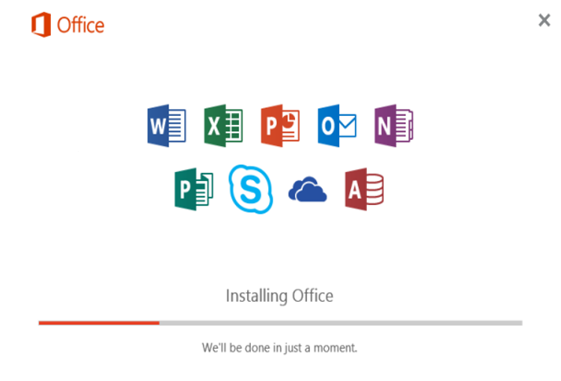

- You will be prompted with the Microsoft Office License Agreement. View the agreement and click ‘Accept’.
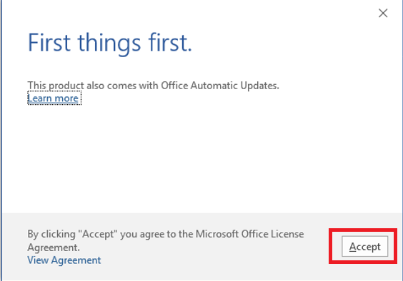

- After Office 2016 finishes installing, a message will appear to inform it has completed. Click ‘Close’.
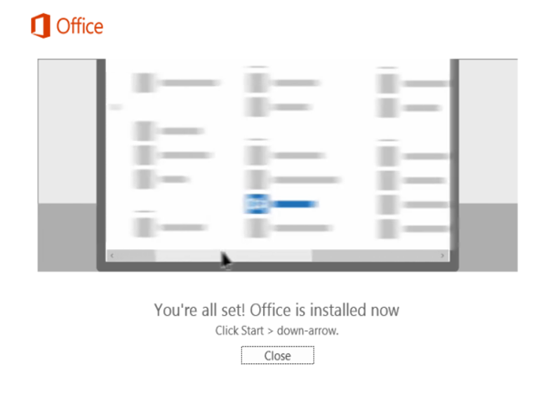
After you click ‘Close’, we recommend restarting your computer to ensure all changes have applied successfully.

When you open up an Office application, you will be prompted with the message to say that the product comes with Office Automatic Updates. Click Accept.

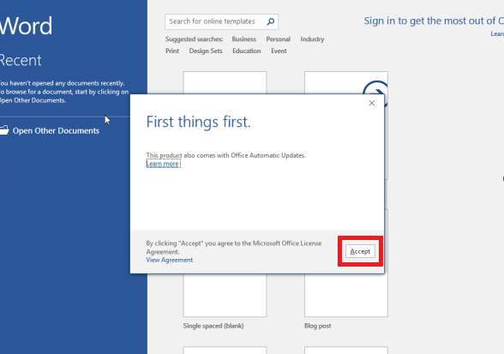

Click ‘Sign in to get the most out of Office’ in the top right hand corner.

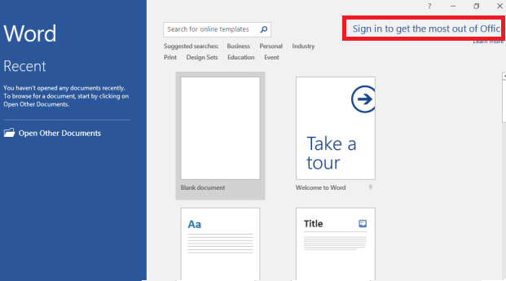

You will be prompted to sign in.

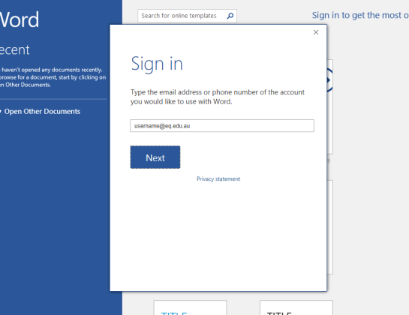

Enter your EQ email (username@eq.edu.au). Press Next.

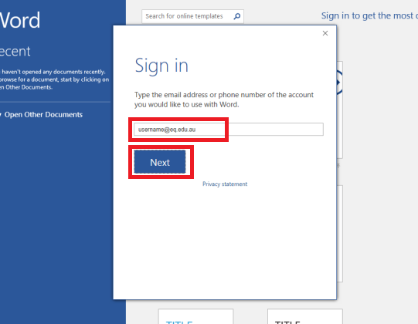

You will need to enter your details into the online authentication page and click Login.

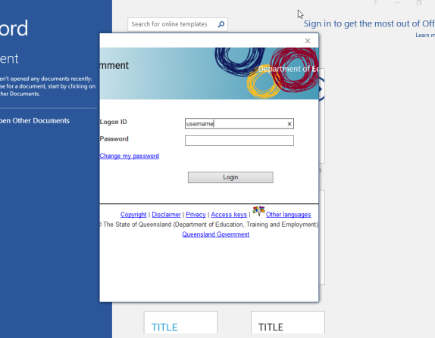

It will take you back to the main window of the application. You will see that your name and user name will appear as well as your email address.
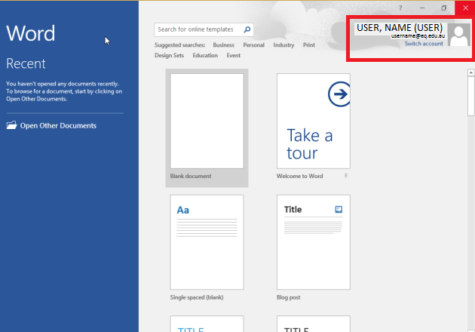

Your Microsoft Office 2016 software is now ready for you to use. This software is only for personal devices and will remain available as long as you are a Queensland state school student, or employed by the department.

For staff, contact the Service Centre by logging a job or calling 1800 680 445 if you have any issues with downloading or installing Office 2016. For students, contact your school technician or Managed Internet Service (MIS) administrator.

